BTI325 Assignment 3

# Submission Deadline:

Section A& C: Sunday, Oct 21, 2018 @ 11:59 PM

Section B: Tuesday, Oct 23, 2018 @ 11:59 PM

# Assessment Weight:

9% of your final course Grade

# Objective:

Build upon the foundation established in Assignment 2 by providing new routes / views to support adding new employees and uploading images.

**NOTE:** If you are unable to start this assignment because Assignment 2 was incomplete - email your professor for a clean version of the Assignment 2 files to start from (effectively removing any custom CSS or text added to your solution).

# Specification:

For this assignment, we will be enhancing the functionality of Assignment 2 to include new routes & logic to handle file uploads and add employees. We will also add new routes & functionality to execute more focused queries for data (ie: fetch an employee by id, all employees by a department or manager number, etc)

# Part 1: Adding / Updating Static (.html) Files & Directories

### **Step 1:** Modifying home.html & about.html (refer to the following screenshots)

* Open the home.html file from within the "views" folder
* Add the following two entries to the **<ul class="nav navbar-nav">** element:
  + <li><a href="/employees/add">Add Employee</a></li>
  + <li><a href="/images/add">Add Image</a></li>
* Add the following entry as the **first child** element of the **<ul class="nav navbar-nav navbar-right">** element
  + <li><a href="/images">Images</a></li>
* Your "Home" page should now have a menu bar that looks like the following:



* Update your "About" page with the same changes. When complete, it should look like the following:



### **Step 2:** Adding new routes in server.js to support the new views

* Inside your server.js file add the following routes (HINT: do not forget __dirname & path.join):
  + GET /employees/add
    - This route simply sends the file "/views/addEmployee.html "
  + GET /images/add
    - This route simply sends the file "/views/addImage.html

### **Step 3:** Adding new file 1: addEmployee.html

* Create a new file in your "views" directory called "addEmployee.html" and open it for editing
* Copy the contents of "home.html" and paste it in as a starting point.
* Ensure that the "Add Employee" item in the **<ul class="nav navbar-nav"> …</ul>** element is the **only** <li> with the class "active" (this will make sure the correct navigation element is "highlighted")
* Remove all html code **inside** the **<div class="row">** … **</div>**
* Inside the (now empty) **<div class="row">** … **</div>** element, use the following sample html  
  (<https://github.com/sunnyDay100/BTI325/blob/master/A3/addEmployee.html> ) to reconstruct the "Add Employee" form. Change my name after <span class="navbar-brand" href="#"> with your name.
* HINT: You can right-click the page to "view source" - the html you want is within the **<div class="row"> …</div>** element.

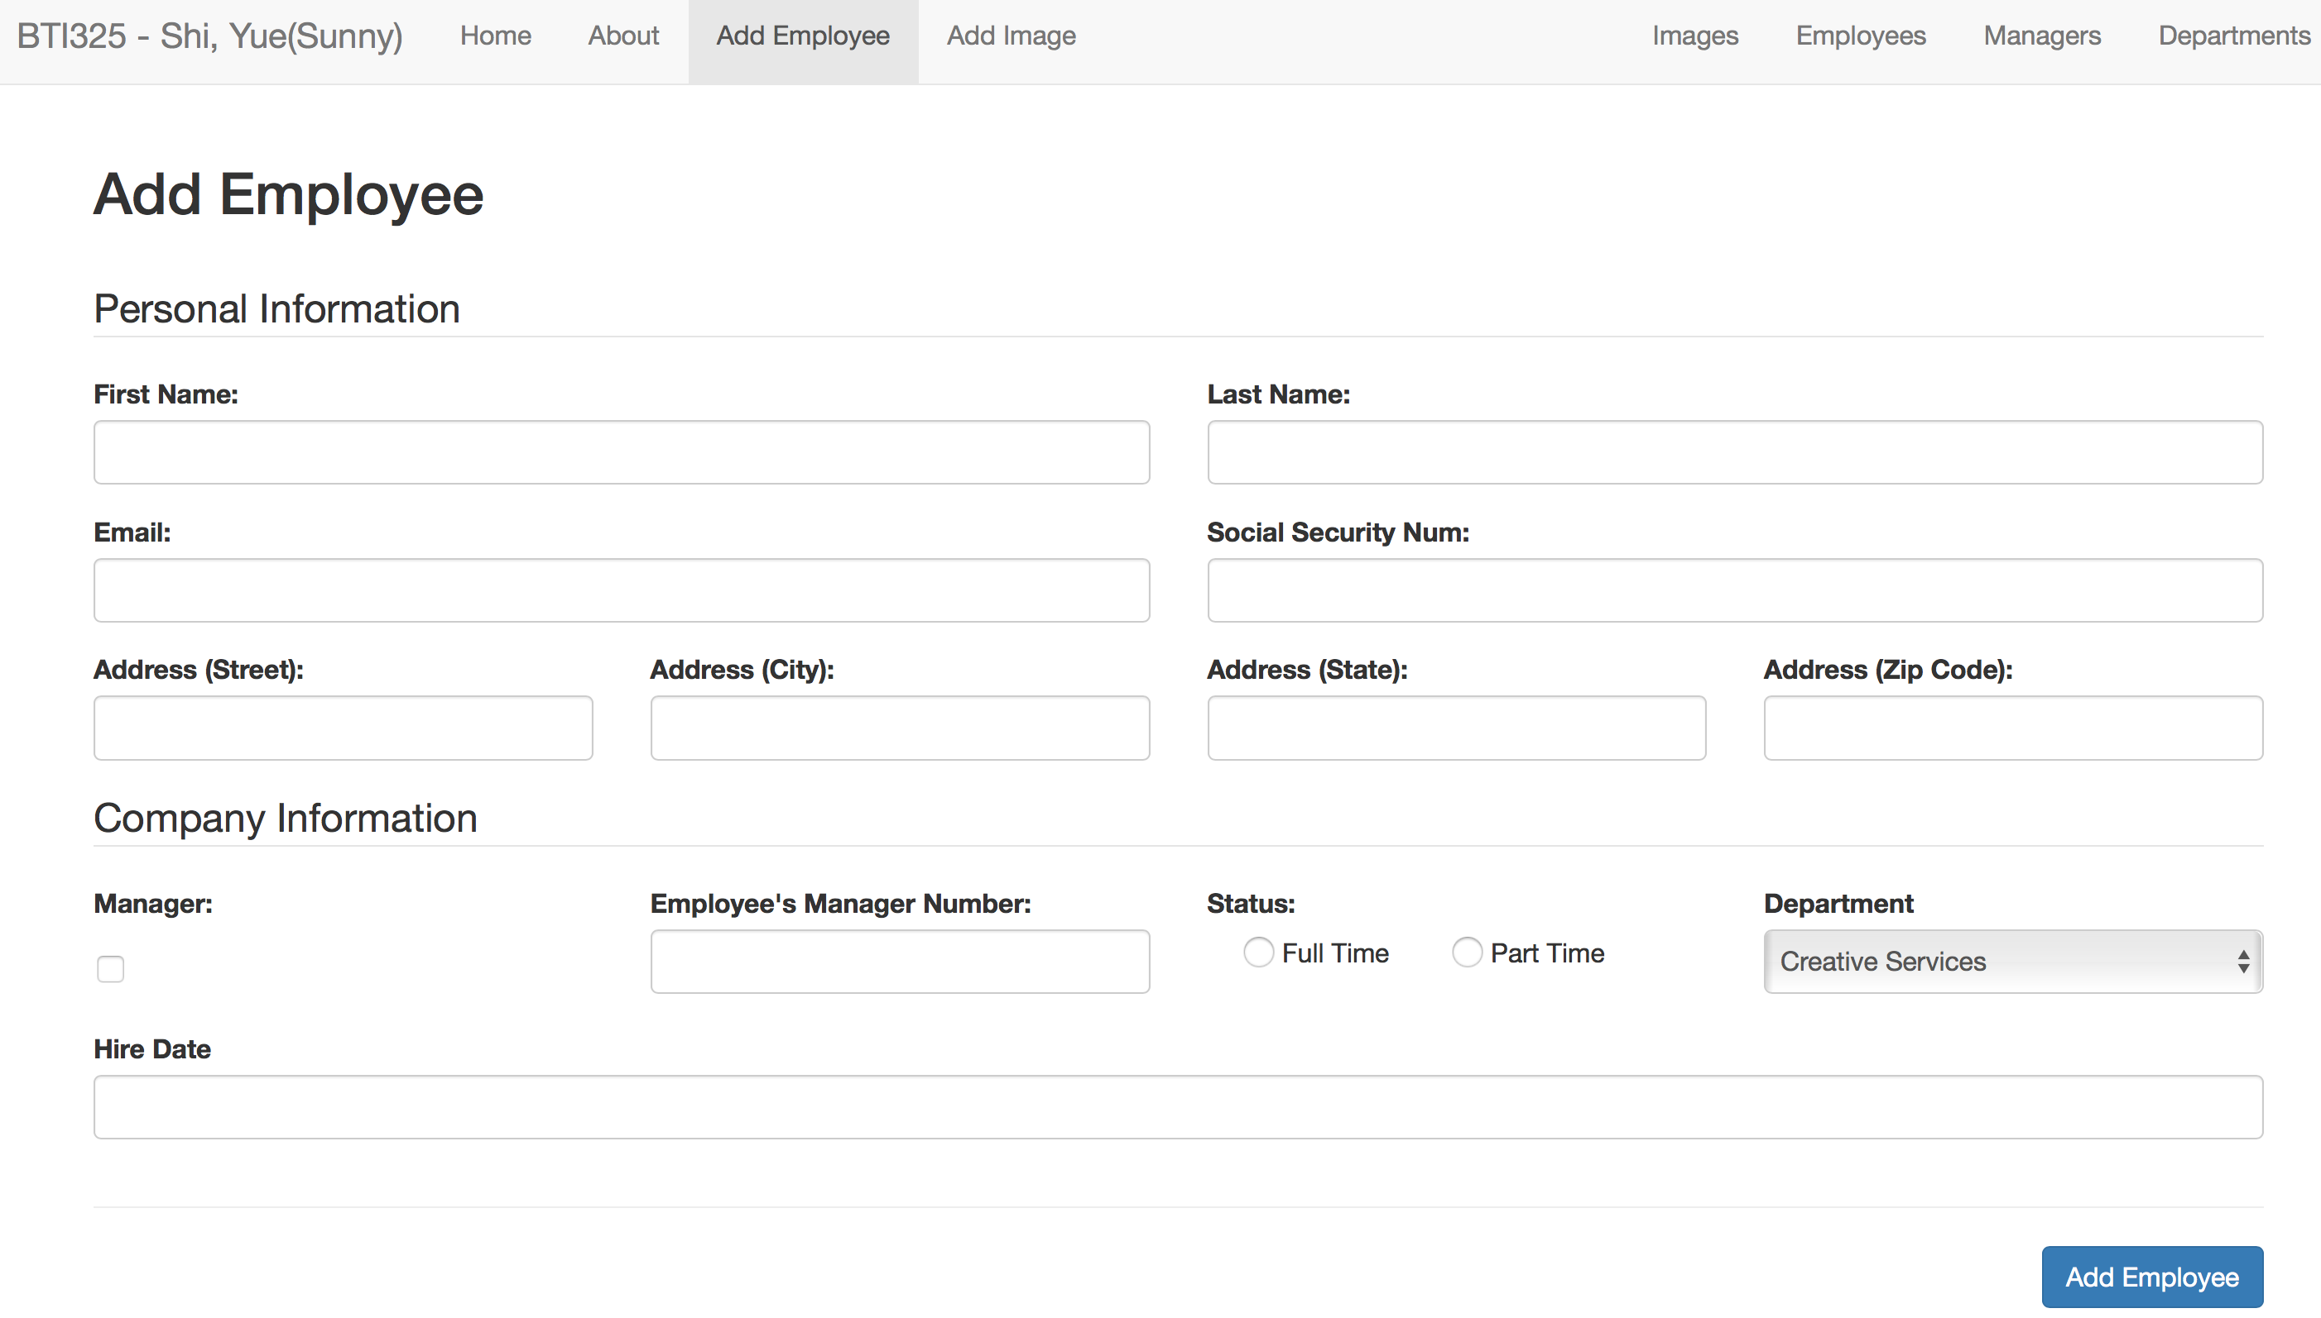

### **Step 4:** Adding new file 2: addImage.html

* Create a new file in your "views" directory called "addImage.html" and open it for editing
* Copy the contents of "home.html" and paste it in as a starting point.
* Ensure that the "Add Image" item in the **<ul class="nav navbar-nav"> …</ul>** element is the **only** <li> with the class "active" (this will make sure the correct navigation element is "highlighted")
* Remove all html code **inside** the **<div class="row">** … **</div>**
* Inside the (now empty) **<div class="row">** … **</div>** element, use the following sample html  
  (<https://github.com/sunnyDay100/BTI325/blob/master/A3/addImage.html> ) to reconstruct the "Add Image" form. Change my name after <span class="navbar-brand" href="#"> with your name.
* HINT: You can right-click the page to "view source" - the html you want is within the **<div class="row"> …</div>** element

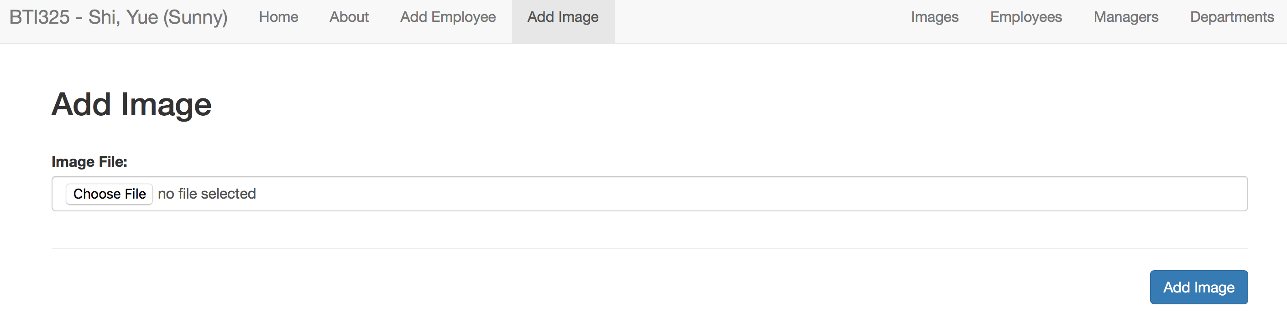

### **Step 5:** Adding a home for the uploaded Images

* Create a new folder in your "public" folder called "images"
* Within the newly created "images" folder, create an "uploaded" folder

# Part 2: Adding Routes / Middleware to Support Image Uploads

### **Step 1:** Adding multer

* Use npm to install the "multer" module
* Inside your server.js file "require" the "multer" module as "multer"
* Define a "storage" variable using "multer.diskStorage" with the following options (HINT: see "Step 5: (server) Setup…" in the [week 5 course notes](http://zenit.senecac.on.ca/~patrick.crawford/index.php/web322/course-notes/week5-class1/) for additional information)
  + **destination** "./public/images/uploaded"
  + **filename** function (req, file, cb) {

cb(null, Date.now() + path.extname(file.originalname));

}

* Define an "upload" variable as **multer({ storage: storage });**

### **Step 2:** Adding the "Post" route

* Add the following route:
  + POST /images/add
    - This route uses the middleware: **upload.single("imageFile")**
    - When accessed, this route will redirect to "/images" (defined below)

### **Step 3:** Adding "Get" route / using the "fs" module

* Before we can add the below route, we must include the **"fs" module** in our **server.js** file (previously only in our data-service.js module)
* Next, Add the following route:
  + GET /images
    - This route will return a JSON formatted string (res.json()) consisting of a single "images" property, which contains the contents of the "./public/images/uploaded" directory as an array, ie { "images": ["1518109363742.jpg", "1518109363743.jpg"] }. **HINT:** You can make use of the **fs.readdir** method, as outlined in [this example from code-maven.com](https://code-maven.com/list-content-of-directory-with-nodejs)

### **Step 4:** Verify your Solution

At this point, you should now be able to upload images using the "/images/add" route and see the full file listing on the "/images" route in the format: { "images": ["1518109363742.jpg", "1518109363743.jpg"] } .

# Part 3: Adding Routes / Middleware to Support Adding Employees

### **Step 1:** Adding body-parser

* Use npm to install the "body-parser" module
* Inside your server.js file "require" the "body-parser" module as "bodyParser"
* Add the bodyParser.urlencoded({ extended: true }) middleware (using app.use())

### **Step 2:** Adding "Post" route

* Add the following route:
  + POST /employees/add
    - This route makes a call to the (promise-driven) addEmployee(employeeData) function from your data-service.js module **(function to be defined below**). It will provide **req.body** as the parameter, ie "data.addEmployee(req.body)".
    - When the addEmployee function resolves successfully, redirect to the "/employees" route. Here we can verify that the new employee was added

### **Step 3:** Adding "addEmployee" function within data-service.js

* Create the function "addEmployee(employeeData)" within data-service.js according to the following specification: (**HINT**: do not forget to add it to module.exports)
  + Like all functions within data-service.js, this function must return a Promise
  + If **employeeData.isManager** is undefined, explicitly set it to **false**, otherwise set it to **true** (this gets around the issue of the checkbox not sending "false" if it's unchecked)
  + Explicitly set the **employeeNum** property of **employeeData** to be the **length of the "employees"** array **plus one (1)**. This will have the effect of setting the first new employee number to 281, and so on.
  + **Push** the updated **employeeData** object onto the **"employees"** array and **resolve** the promise.

### **Step 4:** Verify your Solution

At this point, you should now be able to add new employees using the "/employees/add" route and see the full employee listing on the "/employees" route.

# Part 4: Adding New Routes to query "Employees"

### **Step 1:** Update the "/employees" route

* In addition to providing all of the employees, this route must now also support the following optional filters (via the query string)
  + /employees?status=***value***
    - return a JSON string consisting of all employees where ***value*** could be either "Full Time" or "Part Time" - this can be accomplished by calling the **getEmployeesByStatus(status)** function of your data-service (defined below)
  + /employees?department=***value***
    - return a JSON string consisting of all employees where ***value*** could be one of 1, 2, 3, … 7 (there are currently 7 departments in the dataset) " - this can be accomplished by calling the **getEmployeesByDepartment(department)** function of your data-service (defined below)
  + /employees?manager=***value***
    - return a JSON string consisting of all employees where ***value*** could be one of 1, 2, 3, … 30 (there are currently 30 managers in the dataset) " - this can be accomplished by calling the **getEmployeesByManager(manager)** function of your data-service (defined below)
  + /employees
    - return a JSON string consisting of all employees without any filter (existing functionality)

### **Step 2:** Add the "/employee/value" route

* This route will return a JSON formatted string containing the employee whose **employeeNum** matches the ***value***. For example, once the assignment is complete, **localhost:8080/employee/6** would return the manager: **Cassy Tremain -** - this can be accomplished by calling the **getEmployeeByNum(num)** function of your data-service (defined below).

# Part 5: Updating "data-service.js" to support the new "Employee" routes

**Note**: All of the below functions must return a **promise** (continuing with the pattern from the rest of the data-service.js module)

### **Step 1:** Add the getEmployeesByStatus(status) Function

* This function will provide an array of "employee" objects whose **status** property matches the ***status*** parameter (ie: if ***status*** is "Full Time" then the array will consist of only "Full Time" employees) using the **resolve** method of the returned promise.
* If for some reason, the length of the array is 0 (no results returned), this function must invoke the **reject** method and pass a meaningful message, ie: "no results returned".

### **Step 2:** Add the getEmployeesByDepartment(department) Function

* This function will provide an array of "employee" objects whose **department** property matches the ***department*** parameter (ie: if ***department*** is 5 then the array will consist of only employees who belong to department 5 ) using the **resolve** method of the returned promise.
* If for some reason, the length of the array is 0 (no results returned), this function must invoke the **reject** method and pass a meaningful message, ie: "no results returned".

### **Step 3:** Add the getEmployeesByManager(manager) Function

* This function will provide an array of "employee" objects whose **employeeManagerNum** property matches the ***department*** parameter (ie: if ***manager*** is 14 then the array will consist of only employees who are managed by employee 14 ) using the **resolve** method of the returned promise.
* If for some reason, the length of the array is 0 (no results returned), this function must invoke the **reject** method and pass a meaningful message, ie: "no results returned".

### **Step 3:** Add the getEmployeeByNum(num) Function

* This function will provide a single of "employee" object whose **employeeNum** property matches the ***num*** parameter (ie: if ***num*** is 261 then the "employee" object returned will be "Glenine Focke" ) using the **resolve** method of the returned promise.
* If for some reason, the length of the array is 0 (no results returned), this function must invoke the **reject** method and pass a meaningful message, ie: "no results returned".

# Part 6: Pushing to Heroku

Once you are satisfied with your application, deploy it to Heroku:

* Ensure that you have checked in your latest code using **git** (from within Visual Studio Code)
* Open the integrated terminal in Visual Studio Code
* Log in to your Heroku account using the command **heroku login**
* Create a new app on Heroku using the command **heroku create**
* Push your code to Heroku using the command **git push heroku master**
* **IMPORTANT NOTE:** Since we are using an "**unverified" free** account on Heroku, we are limited to only **5 apps**, so if you have been experimenting on Heroku and have created 5 apps already, you must delete one (or verify your account with a credit card). Once you have received a grade for Assignment 1, it is safe to delete this app (login to the Heroku website, click on your app and then click the **Delete app…** button under "**Settings**").

## Assignment Submission:

* Before you submit, consider updating **site.css** to provide additional style to the pages in your app. Black, White and Gray is boring, so why not add some cool colors and fonts (maybe something from   
  [Google Fonts](https://fonts.google.com/))? This is your app for the semester, you should personalize it!
* Next, Add the following declaration at the top of your **server.js** file:

/*********************************************************************************  
* BTI325 – Assignment 3  
* I declare that this assignment is my own work in accordance with Seneca Academic Policy. No part   
* of this assignment has been copied manually or electronically from any other source   
* (including 3rd party web sites) or distributed to other students.  
*   
* Name: ______________________ Student ID: ______________ Date: ________________  
*  
* Online (Heroku) Link: ________________________________________________________  
*  
********************************************************************************/

* Compress (.zip) your web322-app folder and submit the .zip file to My.Seneca under   
  **Assignments** -> **Assignment** 3

## Important Note:

* Compress (.zip) your bti325-app folder and submit the .zip file to My.Seneca under   
  **Assignments** -> **A**3
* Late submission will be penalized with 10% of this assignment marks for each school day up to 5 school days, after which it will receive 0 marks.